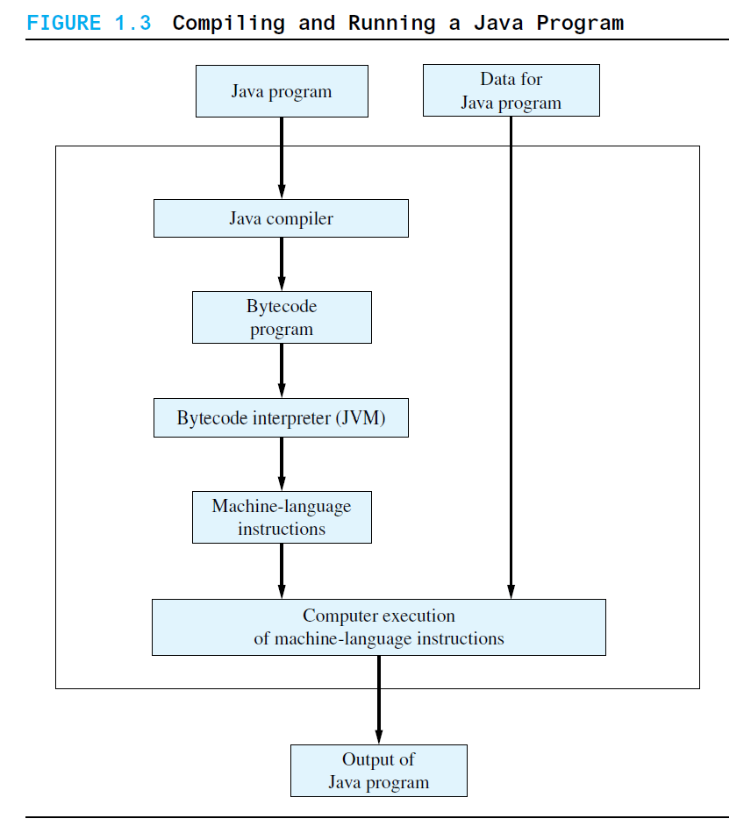

**Sumber:** An Introduction to Problem Solving & Programming EIGHTH EDITION Walter Savitch

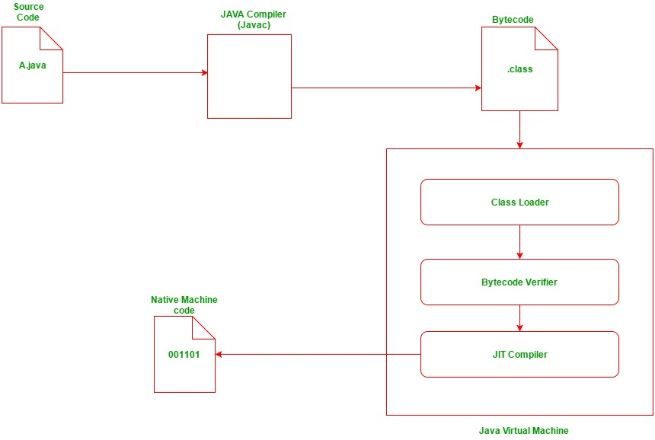

**Sumber:** https://www.geeksforgeeks.org/compilation-execution-java-program/

**Java Program ( Source Code : xxx.java)**

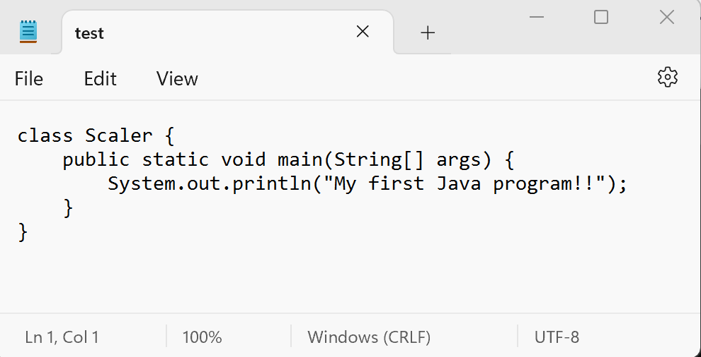

**Java Compiler ( Javac )**

**Bytecode Program ( xxx.class)**

Computer Execution

Catatan:

RECAP Bytecode

The Java compiler translates your Java program into a language called bytecode. This bytecode is not the machine language for any particular computer, but it is similar to the machine language of most common computers. Bytecode is easily translated into the machine language of a given computer. Each type of computer will have its own translator—called an interpreter—that translates from bytecode instructions to machine-language instructions for that computer.

**What is Pseudocode**

Pseudocode is a method of describing computer algorithms using a combination of natural language and programming language constructs. It is not a formal programming language, but rather a way of expressing algorithms in a way that is more easily understood by humans. Pseudocode is often used as an intermediate step in the development of a program, before the final code is written in a specific programming language.